Path Testing

What is Path Testing
# Source: AI Source: Provided by: [Data Path: Persons Table -> ID Column: 1, Name_En Column: Motasem Essam] -> From: [ChatGPT] on [8/24/2025]
Path Testing is a white-box testing technique where the goal is to design test cases that ensure all possible execution paths through the code are tested at least once.
A path is simply a unique route through the program’s control flow (from start to end), considering decisions, loops, and branches.

🔍 Example:
# Source: AI Source: Provided by: [Data Path: Persons Table -> ID Column: 1, Name_En Column: Motasem Essam] -> From: [ChatGPT] on [8/24/2025]
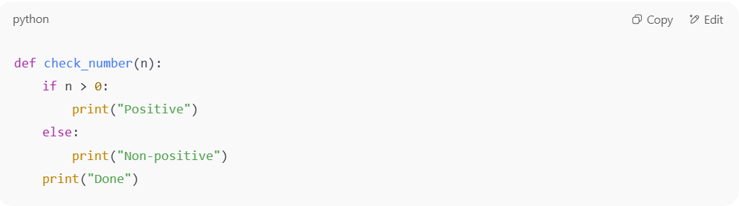
def check_number(n):
if n > 0:
print("Positive")
else:
print("Non-positive")
print("Done")

- Possible paths:
  - Enter function → n > 0 True → "Positive" → "Done"
  - Enter function → n > 0 False → "Non-positive" → "Done"
✅ Path Testing requires test cases that cover both paths.

🔍 Example with Loop:
# Source: AI Source: Provided by: [Data Path: Persons Table -> ID Column: 1, Name_En Column: Motasem Essam] -> From: [ChatGPT] on [8/24/2025]
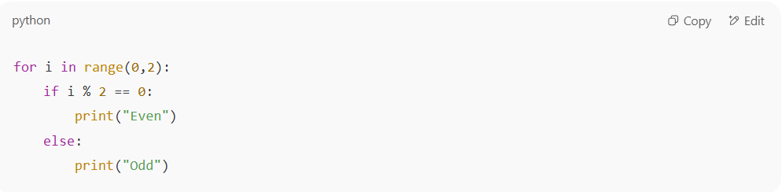
for i in range(0,2):
if i % 2 == 0:
print("Even")
else:
print("Odd")

- Paths:
  - Loop executes twice. Within each iteration, two branches exist (i % 2 == 0 True/False).
  - Paths to cover:
    - i=0 → Even
    - i=1 → Odd
✅ To achieve path coverage, tests must run through both outcomes.

📊 Formula for Path Coverage:
# Source: AI Source: Provided by: [Data Path: Persons Table -> ID Column: 1, Name_En Column: Motasem Essam] -> From: [ChatGPT] on [8/24/2025]
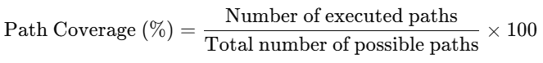
Path Coverage (%)=Number of executed pathsTotal number of possible paths×100\text{Path Coverage (\%)} = \frac{\text{Number of executed paths}}{\text{Total number of possible paths}} \times 100

✅ Why is Path Testing useful?
# Source: AI Source: Provided by: [Data Path: Persons Table -> ID Column: 1, Name_En Column: Motasem Essam] -> From: [ChatGPT] on [8/24/2025]
- Ensures maximum coverage of program flow.
- Detects errors in control structures, loops, and complex decision-making.
- Stronger than statement, decision, or condition testing because it considers the sequence of execution.

⚖️ Advantages:
# Source: AI Source: Provided by: [Data Path: Persons Table -> ID Column: 1, Name_En Column: Motasem Essam] -> From: [ChatGPT] on [8/24/2025]
- Very thorough — ensures all possible routes are tested.
- Finds hidden defects in rarely executed paths.

⚠️ Limitations:
# Source: AI Source: Provided by: [Data Path: Persons Table -> ID Column: 1, Name_En Column: Motasem Essam] -> From: [ChatGPT] on [8/24/2025]
- Path explosion problem: Number of paths can grow exponentially with decisions and loops.
  - Example: With just 10 binary decisions → 210=10242^{10} = 1024 paths!
- Not practical for large systems → often combined with basis path testing (using Cyclomatic Complexity to limit test cases).

✅ In short:
Path Testing ensures that every unique execution path in the program is tested at least once, making it one of the strongest white-box testing techniques, though expensive for complex programs.

Difference between Path Testing, MCC, Condition Testing and Decision Testing
# Source: AI Source: Provided by: [Data Path: Persons Table -> ID Column: 1, Name_En Column: Motasem Essam] -> From: [ChatGPT] on [8/24/2025]
These terms all belong to white-box testing, but they focus on different levels of thoroughness when exercising code logic. Let’s break them down clearly with differences.

🔹 1. Branch (Decision) Testing & Coverage
- Coverage Item: Branches (true/false outcomes of each decision).
- Goal: Ensure every decision outcome (yes/no, true/false) is executed at least once.
- Example:
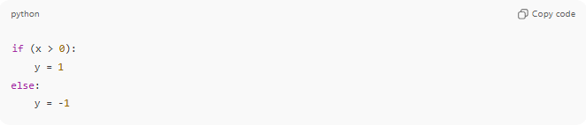
if (x > 0):
y = 1
else:
y = -1
- Branches: x > 0 = True and x > 0 = False.
- Needs 2 tests (x = 5, x = -5).
✅ Ensures all decision outcomes are tested.
❌ Does not guarantee all conditions inside a decision are tested separately.

🔹 2. Condition Testing
- Coverage Item: Individual Boolean conditions inside a decision.
- Goal: Ensure each atomic condition (e.g., A, B in (A AND B)) evaluates to both True and False at least once.
- Example:
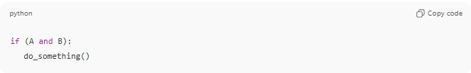
if (A and B):
do_something()
- Conditions: A, B.
- Must test both true and false values of A, and both true and false values of B.
✅ Stronger than branch testing.
❌ Doesn’t ensure all combinations of conditions are tested.

🔹 3. Multiple Condition Coverage (MCC)
- Coverage Item: All possible combinations of conditions in a decision.
- Goal: Ensure every possible truth table combination of the conditions is exercised.
- Example: (A AND B) has 2 conditions → 2² = 4 combinations.
- Test Cases:
  - A=T, B=T
  - A=T, B=F
  - A=F, B=T
  - A=F, B=F
✅ Stronger than condition testing, guarantees every combination.
❌ May lead to combinatorial explosion with many conditions.

🔹 4. Path Testing
- Coverage Item: Execution paths through the program.
- Goal: Ensure every unique path through the control flow graph is executed.
- Example:
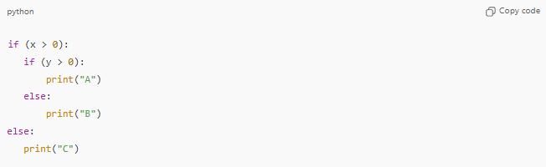
if (x > 0):
if (y > 0):
print("A")
else:
print("B")
else:
print("C")
- Paths:
  - x>0 & y>0 → A
  - x>0 & y<=0 → B
  - x<=0 → C
✅ Strongest – exercises full paths, not just conditions.
❌ Can be infinite/unfeasible in loops (so often limited to “basis paths” or “prime paths”).

📊 Quick Comparison Table
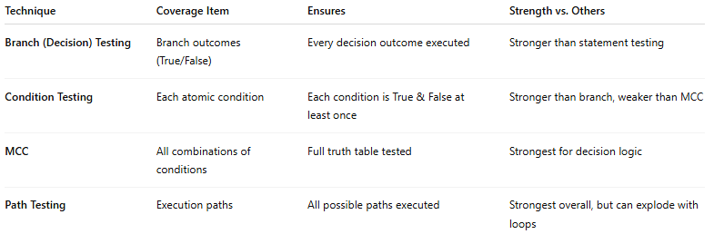
Technique | Coverage Item | Ensures | Strength vs. Others
Branch (Decision) Testing | Branch outcomes (True/False) | Every decision outcome executed | Stronger than statement testing
Condition Testing | Each atomic condition | Each condition is True & False at least once | Stronger than branch, weaker than MCC
MCC | All combinations of conditions | Full truth table tested | Strongest for decision logic
Path Testing | Execution paths | All possible paths executed | Strongest overall, but can explode with loops

👉 In short:
- Branch testing = outcomes.
- Condition testing = each condition flips.
- MCC = all combinations of conditions.
- Path testing = all program paths.

